Contents
No table of contents entries found.

THE MATRIX AND ALICE IN WONDERLAND PARALLELS

The Rabbit
The Matrix begins as an apparently standard story about a regular guy with a normal desk job in a normal city. But this guy works clandestinely as a secretive hacker that goes by the name Neo. Suddenly Neo is tossed into a world completely new to him but is in fact reality, and the life he thought he was living turned out to be a computer replication called the matrix. In a handful of scenes in the movie, there a precise reference to Lewis Carroll’s fanciful novels Through the Looking Glass and Alice in Wonderland. Lewis Carroll’s writings have been largely distributed through American culture through movies and other forms of media before The Matrix was released in theaters. For instance, Walt Disney’s [copyright] Alice in Wonderland came out in the US in 1951, and Jan Svankmajer’s film Alice or Neco z Alenky was released in the US in 1988.
In the start of the movie, Neo gets woken up by his computer sending him a message ordering him to “Follow the white rabbit.” Neo then hears a knock on the door from one of his clients and a girl with a rabbit tattoo. In another part with Morpheus (the man from the actual world trying to recruit Neo) offers Neo a decision: to join them, or to forget what they’ve told him and endure in his fake reality. But the wording of which Morpheus offers the choices to Neo refers to the story of Alice in Wonderland:

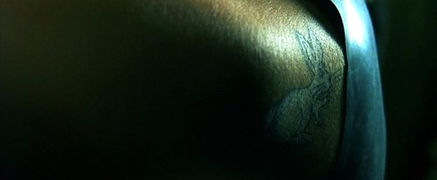
The Pill
Published November 26th, 1865. “You take the blue pill, the story ends, you wake up in your bed and believe whatever you want to believe. You take the red pill, you stay in Wonderland, and I show you how deep the rabbit hole goes.”
By reiterating the word “rabbit” and including “Wonderland” and “rabbit hole,” the viewers draw on their personal experience of their knowledge of Alice in Wonderland and subconsciously compare Neo’s trip to that of Alice. Even as Morpheus clutches out the two pills in distinct hands, the idea that “one will make you forget, and one will make you see the truth” compares to “one will make you bigger and one will make you smaller,” when Alice meets the caterpillar. This point in the story of The Matrix indicates Neo entering a bizarre and unaccustomed world. Although Alice eventually wakes up from her dream in Wonderland, when Neo wakes up, it is the reverse. Instead, for Neo, Wonderland is the real world.
There was a remake with Johnny Depp.
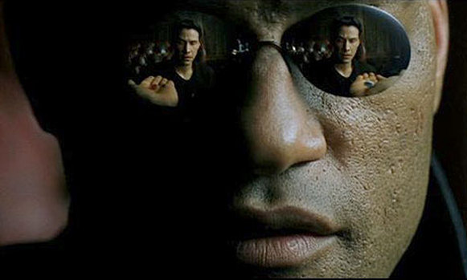
Overall, The Matrix comprises thought provoking and philosophical notions about reality in addition to amazing costumes, set designs, and action that make this thrills-packed movie an instant classic.

The Matrix Trilogy:
The Matrix
The Matrix Reloaded
The Matrix Revolutions

Miami | $40M
LA | $25M
NYC | $35M

Character Name Real Name
Neo Keanu Reeves
Morpheus Lawrence Fishburne
Trinity Carrie-Anne Moss

