My Vacation to Vermont

In the winter of 2015 my daughter, Sarah, and I went on a snow/ski vacation to Smuggler’s Notch resort in Vermont. She had never seen snow before and I had never been skiing before so I decided that would be a great place to go on a vacation. I did lots of research on the internet to find a kid friendly resort that wasn’t totally dedicated to skiing since I wanted her to experience other snow related fun times.
At first I figured I could just hop on a last minute flight and book a hotel room anywhere in the eastern part of America that had snow during the 2 weeks we were on winter vacation, but wouldn’t you know it, the entire eastern half of America had no snow the week of winter break. Thanks global warming! So the next year I decided to book a trip and cross my fingers.
I book Smuggler’s Notch and 5 days before the trip they called me and told they had no snow. It was happening again. I couldn’t believe it and this time I bought airplane tickets that were non-refundable. I told the resort people that I wanted to reschedule the trip for the middle of winter when there a 99% chance that there would be lots of snow. They accommodated me and I was able to change my flight for a $200 fee. Luckily booking the resort in February instead of over the holidays saved me about $200 since they weren’t as busy so I basically broke even.
Anyway, the trip went great. I was snowing when we got there so my daughter was able to see snow falling from the sky which was definitely important to me. We played in the snow, made snow angels and tried to make snowballs but the snow was too powdery.
Some activities that we participated in on the snow mountain were snowmobiles, bonfires with hot chocolate, skiing with lessons, the Ben and Jerry’s ice cream shop and snow tubing (my favorite). It wasn’t all fun and games though. Renting and lugging all that ski equipment was definitely hard work. The boots were very hard to walk in. There was also the skis, helmet, poles and goggles. Combined with wearing warm layers, it took about an hour just to get dressed and downstairs.
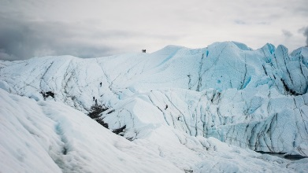

Smuggler’s Notch is Da’ Bomb!

There were so many family friendly places to go and activities to do! Check out the partial list below:

- Snowmobiles
- Tubing
- Skiing
- Outdoor ice skating
- Fun zone
- Zip lines
- Ben and jerry’s ice cream shop
- Sno-Cat’s
- Winter walking

